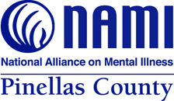
13830 N. 58th Street Suite 413
Clearwater FL 33760
(O) 727-826-0807
Information & Resource Helpline 727-791-3434

Central Florida Behavioral Network
719 US-301
Tampa, FL 33619

October 31st, 2023

Janet Higgins-Weston and Sarah Andrade,
In connection with an audit of the financial statements of NAMI Pinellas County, Florida, Inc. as of June 30, 2023 and for the year then ended, our independent auditors, Fontana CPAs wish to determine whether our records of grant activity agree with yours. For each grant, contract, or other form of assistance, please provide them with the following information:
Grant Name Adult Mental Health
Grant Number QG119
Subject to Federal Single Audit: Yes ______ No______
If yes, please supply Federal CFDA# _________________
Subject to Florida Single Audit: Yes ______ No______
If yes, please supple State CSFA#_________________
Grant Period July 1, 2022 to June 30, 2023_
Grant Amount:

Federal funds $____________
State funds $_309,208
Local funds $____________
Total grant award $_309,208__

Amount of funds paid during the year ended June 30, 2023:

Federal funds $____________
State funds $_309,208
Local funds $____________
Total funds paid $____________

Requests relating to year ended June 30, 2023
but not paid prior to June 30, 2023 $_40,221

Page 2

Remaining Grant Amount
Federal funds $__________________
State funds $__________________
Local funds $__________________
Total remaining $_0_________________

Is a Match required Yes _x_____ No_____
Amount of Match required $_102,039.00

Required source of Match $__________________

Amount of advances due as of
June 30, 2023 $__________________

Repayments or disallowances due as of
June 30, 2023 $__________________

Please send this information directly to our independent auditor, Fontana CPAs, 13007 West Linebaugh Ave, Tampa FL 33626 or email to shelley@fontanacpas.com.
Very truly yours,
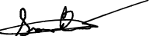
Siomara Bridges-Mata
Executive Director

Form completed by:

Company ____________________________
Name ____________________________
Signature ____________________________
Title ____________________________
Phone # ____________________________
Date ____________________________
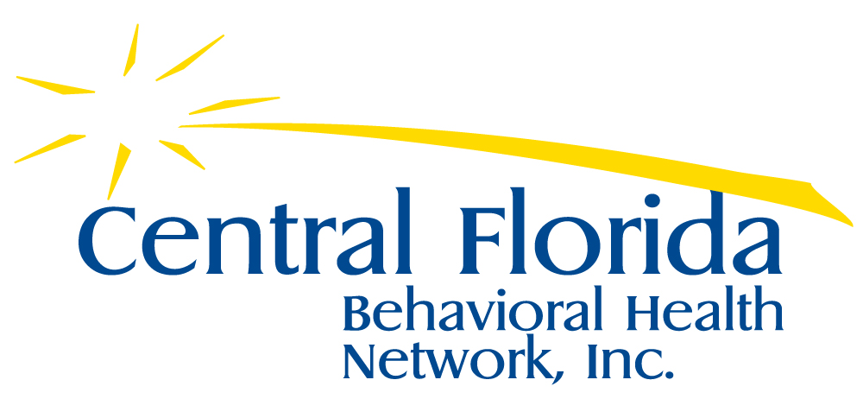
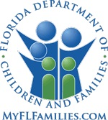
nami-pinellas.org|13830 N. 58th Street, Suite 413, Clearwater FL 33760 |
@NamiPinellas
nami-pinellas.org|13830 N. 58th Street, Suite 413, Clearwater FL 33760 |
@NamiPinellas
nami-pinellas.org|13830 N. 58th Street, Suite 413, Clearwater FL 33760 |

